




PRODUCT DATA

Revision Date 02/25
Page 1 of 2
Product Code HS0108

Cooltech MTC
Machine Tool Cleaner
Cleaning & Maintenance
Product Description
A product that has been designed specifically for use on machine tools that use soluble metalworking fluid. It is a synergistic blend of surfactants, solvents, and building agents used in metalworking fluids to provide a powerful cleaning action on industrial machine tools without interfering with the chemistry of the fluids in use. Cooltech MTC is sold as a concentrate but is also available as a ready-to-use pre-dilute.

Features & Benefits

- Custom dilutable ~ Economical in use
- Non-flammable ~ COSHH benefits - safe use & storage
- No adverse effects on coolant ~ No need to change coolant

Applications
Cooltech MTC, when diluted, can be used to effectively clean most hard surfaces found on machine tools including cabinets, guards, CNC doors & windows, chucks, and tool holders.

Recommended Dilution
Heavy Soiling | Light Soiling
10:1 – 20:1 | 20:1 – 40:1

Adjust spray nozzle to give a fine or course spray depending upon your requirements. Wipe the surface clean with a dry, absorbent lint free wipe or tissue.

Typical Test Data

Appearance | Liquid
Colour | Pink
Odour | Characteristic
Density @ 20°C | 1.06
pH | 10

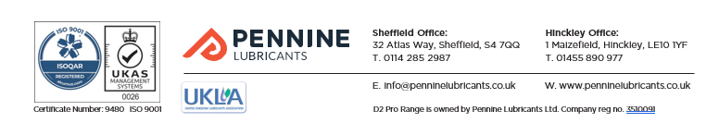

PRODUCT DATA

Revision Date 02/25
Page 2 of 2
Product Code HS0108


Availability
Cooltech MTC is available in 25 litre drums and 5 litre containers.

Storage

Cooltech MTC should always be stored indoors and protected from extremes of temperature. Do not allow to freeze.

Health & Safety
Please refer to the relevant Safety Data Sheet, a copy of which is freely available to all our customers.

Data represented is typical of that obtained with normal production tolerances and does not constitute a specification. The policy of Pennine Lubricants is one of continual improvement, we therefore reserve the right to change specifications without notice.

Cleaning & Maintenance

